**CSC210 – OOP II LAB 4 – MENU, ICON**

1. Write the code to produce the following GUI. When the Login button is clicked, the text field and password values are copied to a file.

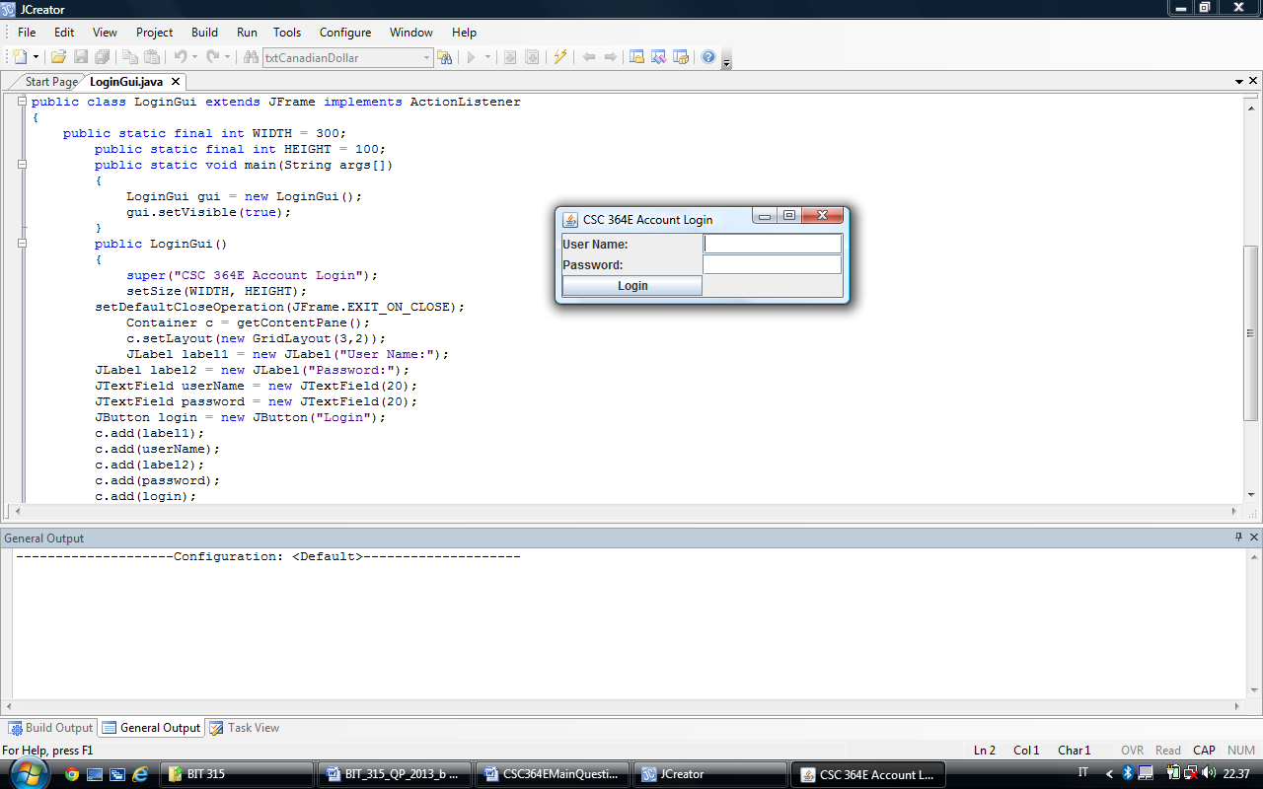

1. Consider the GUI given below. Write a program to generate this user interface. You are given that the program only terminates when the “EXIT” button with the icon is clicked. When the “TOGGLE BACKGROUND COLOR” button is clicked the background color of the text area from WHITE to CYAN and vice versa. When the close window button on the JFrame is clicked nothing happens. You can use the Internet to find icons of your choice. Include in your GUI a text area that is not editable where a short description of the course selected will be displayed

